**SOFTWARE REQUIREMENT SPECIFICATION**

**Website for *Statistics for Social Sciences***

1. **Requirement analysis**

1.1 ***Project study***

The primary aim of our team is to eliminate all the shortcomings from already-available Statistical wizards for Descriptive and Inferential Statistics for non-Statisticians. Some of the most noticeable shortcomings are:

* 1. Poor UI
  2. Negligible explanation about tests
  3. No guiding facility for possible analyses after hypothesis testing
  4. General assumptions are never verified before parametric tests

The website project that our team would create would focus improving/implementing the above-mentioned points.

1.2 ***Domain-specific specialization concepts***

The specialization concepts to be used in our Statistical wizard for Social Sciences are as follows:

1. PHP (XAMPP)
2. HTML
3. Content Management System (CMS) using Open-source software
4. Descriptive Statistics
5. Inferential Statistics
6. Excel/R/Python Plug-ins implementation in websites
7. **Requirements specification**

2.1 ***Functional requirements***

Home Page

1. Gives a brief introduction about our website
2. Displays process and types of tests provided.
3. Information tab provided for ‘About Us’ i.e. about the site, to add a personal touch.

Database Management

1. Storage of the User Data in categorical tables using SQL in encrypted format
2. Storage of the site data and various tests results also Pictures and details of the tests.

Which Test

1. Gives the user an idea of which test would be best suited considering the entered data.
2. Intelligently understanding the data.
3. Displays all the tests present

Calculator

1. Generates a Result for the given data.
2. Presents an inference of the results obtained.
3. Inclusion of all the factors affecting the data.

***2.2 Software requirements***

* Front End Development

HTML

PHP

* Back End Development

SQL

***Hardware Requirements-***

No additional hardware is required other than a Laptop/Desktop.

1. **System models**

3.1 ***Project Abstract***

Our project basically deals with the tools which are used in the field of inferential statistics. Our website is very useful for the people performing research. The main aim of our research is to help every research person specifically belong to the field of arts and are not very familiar with the usage of inferential statistics, since it is a tool used by almost everybody practicing social sciences at various levels.

In today’s time, the most important thing in a research is to choose which statistical tool to be used. There are major chances that one will yield incorrect answers because they have inserted any kind of data and randomly performed tests like t-test or f-test or z-test. The use of an incorrect test makes the study very unreliable and it gives only vague conclusions.

Below is a sketch of which tests our website deals with under specific situations:

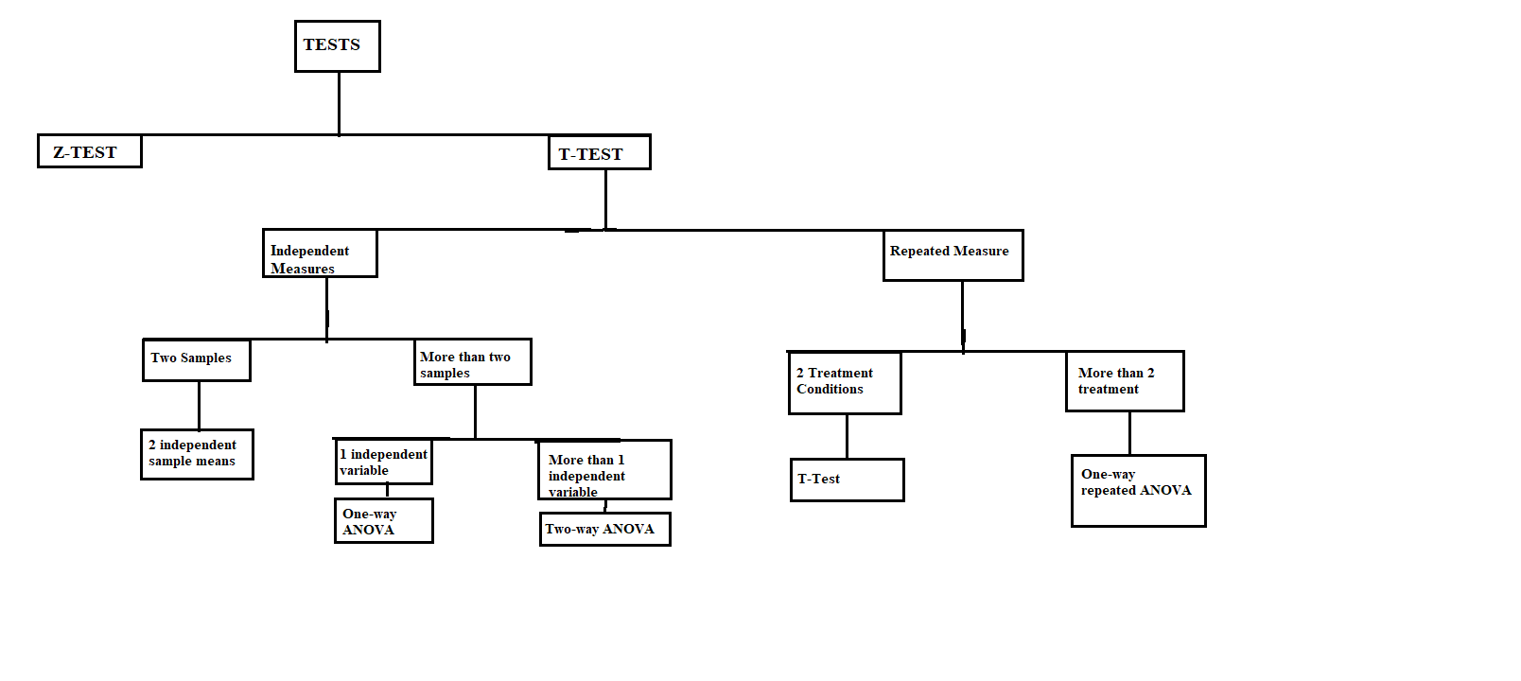

3.2 ***Modules*:**

The various models our website has are:

1. **Home:** The home page of the website consists of the basic description of statistics, its importance and what is the use of the statistical tools in a research. It lets the user know that the website is there to help those who are new to the world of statistics.
2. **Map:** This tab will consist of a flow chart which will help the user to find out what test he or she wants to perform in order to get the best results for his or her research.
3. **Which Test:** If the user is confused that with his or her given data, which test should be performed to proceed further towards the final result, this tab is going to help them. It will contain a list of all the tests which will be provided in the website with its description followed the formula for the test along with an example.
4. **Calculator:** Finally, when the user has decided which test he or she should use to continue with their research, they will have to just fill in the data corresponding to its parameter and the calculator will give the required result.